**USER**

**MANUAL**

INSPECT

**CONTENTS PAGE**

1. OVERVIEW
2. SECTION ONE: GETTING STARTED
   1. Downloading App.
   2. App Permissions.
3. SECTION TWO: MAIN MENU (OVERVIEW OF FEATURES)
   1. Start Inspection
   2. Edit Template
   3. Share File
   4. Create New Template
   5. Back
4. SECTION THREE: CREATING TEMPLATE
5. SECTION FOUR: EDIT TEMPLATE
6. SECTION FIVE: START INSPECTION
7. SECTION SIX: SHARE FILE
8. SECTION SEVEN: TROUBLESHOOTING (?)
9. SECTION EIGHT: FEEDBACK

**OVERVIEW**

**Inspect** is an application used to streamline the inspection process for businesses, bridging the gap between the initial on-site inspection and the digitization process that occurs later. Businesses will be able to create customizable inspection forms/templates that can be edited, filled out and shared with the client with the tap of a screen – this also extends to the feature of being able to take photos, added them and manipulate them with ease to the inspection end result. This would allow for additional information to be easily seen; where defects or other points of interest are accentuated, especially in cases where they may be difficult to discern.

**SECTION ONE: GETTING STARTED**

**2.1 DOWNLOADING THE APP:**

1. Download the Inspect App from Android’s Google Play Store

(Here: <https://play.google.com/apps/testing/com.binarygiant.inspect>)

**[INSERT SCREENSHOT OF APP IN GOOGLE PLAY STORE]**

1. Tap the Inspect App Icon to access the App.

**2.2 APP PERMISSIONS:**

1. Before using the App, ensure that permissions are allowed to access photos, media and files on the device as well as take pictures and record video. This will prove to be useful in the event of adding photos to the inspection form/template that are taken either directly by the camera or the device’s camera gallery as well as being able to locate saved files/templates in the event of editing an existing template or sharing it with a client.

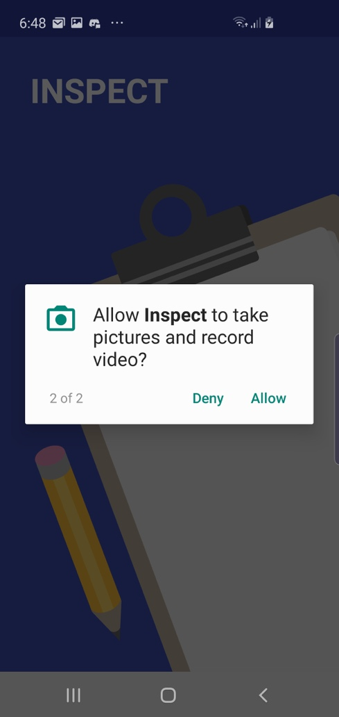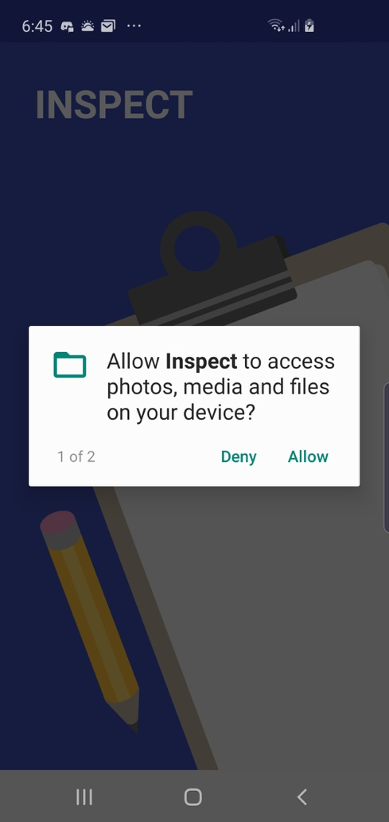

1. Once the Inspect App has been granted these permissions, tap the ‘GET STARTED!’ **[INSERT BUTTON ICON HERE]** button to commence using the App.

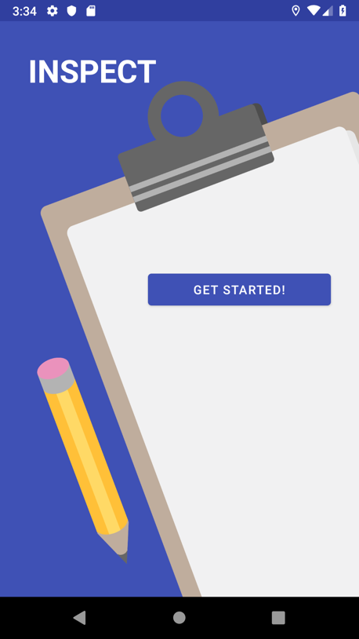

**SECTION TWO: MAIN MENU**

**OVERVIEW OF MAIN MENU BUTTONS/FEATURES**

Located on the main menu are the options:

* 1. **- START INSPECTION:**



Tapping the button will allow the user to select an existing template that has been created and saved and fill it out during on on-site inspection. These additions to the inspection form can be saved and returned to later, previewed, or shared/sent to the client.

* 1. **- EDIT TEMPLATE:**

Tapping the button will allow the user to select an existing template that has been created and saved and make changes to it as per the needs of the inspection. These changes can be saved and returned to later.

* 1. **- SHARE FILE:**

Tapping the button will allow the user to select an existing template that has been created and saved, preview it in the form of a PDF file and share and/or send it to the client accordingly.

* 1. **- CREATE NEW TEMPLATE:**

Tapping the button will allow the user to create their own inspection form with their own customizable headings, questions, placeholders for photos to be attached as well as number of desired pages. This template can be saved and returned to later – either in the process of editing it further through the EDIT TEMPLATE feature or filling it out during the inspection phase through the START INSPECTION feature.

* 1. **- BACK:**



The button will take you back to the previous introductory screen to ‘GET STARTED!’

**SECTION THREE: CREATE A TEMPLATE**

1. To commence the process of creating a template, tap the ‘CREATE A TEMPLATE’ button on the main menu screen.

1. A textbox will appear below the ‘CREATE A TEMPLATE’ button, prompting you to enter the desired name for this template. Once you have named the template, tap the ‘GO’ button to the right of the textbox.

1. A blank template will appear containing a column of pencil icons.

Tapping the icon will allow a horizontal slide menu of buttons to appear across the top of the screen. These can be scrolled through to add custom elements to the template you will be creating.

* To add a Heading to the template, tap the ‘HEADING’ button and enter a heading in the textbox that will appear beside it.

Once you have entered the desired Heading element for your template, simply scroll back to the left of the screen to view the pencil icons to add other elements to your template.

* To add a Short Question to the template, tap the ‘SHORT Q’ button and enter a short question in the textbox that will appear beside it.

* To add a Long Question to the template, tap the ‘Long Q’ button and enter a long question in the textbox that will appear beside it.

* To add a placeholder for a photo to be attached to the template, tap the ‘Add Camera’ button. A photo logo/icon will appear – this will function as a placeholder during the Inspection process for photos to be added in its place. NOTE: You will have to scroll through the horizontal elements menu to access the ‘Add Camera’ button’.

* To go back and edit previous fields or elements, simply tap on the textboxes for each element added to make the necessary changes.

NOTE: To remove any elements you have added, simply tap on the icon next to the element you wish to delete. The icon will appear once you have added an element.

* To preview your current template, tap the ‘PREVIEW’ button at the bottom of the screen. Once you have seen your template previewed, tap on the button to return to your template.

**

1. Once you have created your template and added the desired elements, tap the ‘SAVE’ button at the bottom of the screen to save your template. A brief prompt confirming your template has been saved will then appear.



1. To return to the main menu, tap on the  button at the bottom of the screen.

**SECTION FOUR: EDIT TEMPLATE**

1. To commence the process of editing an existing template that has already been created and saved, tap the ‘EDIT TEMPLATE’ button on the main menu screen.

1. A prompt will appear in front of the main menu, asking you to choose the file you wish to edit. Select the template you have already created and saved.

1. Your saved template will now appear in edit-mode, allowing you to make the desired changes to it.

1. Once you made the desired changes/edits to the template, you may select the ‘PREVIEW’ button at the bottom of the screen to preview your template with these currents changes or tap the ‘SAVE’ button to save these changes.



1. To return to the main menu, tap on the button at the bottom of the screen.

**SECTION FIVE: START INSPECTION**

1. To commence the process of starting an inspection – that is, filling out a custom made template that has already been created and saved – tap on the ‘START INSPECTION’ button on the main menu screen.

1. A prompt will appear above the main menu, asking you to choose the file or template you wish to use for the inspection. Select the desired template for the inspection.

1. Your saved template for inspection will now appear in inspection-mode, allowing you to fill out the template and carry out in the inspection process.

1. During the on-site inspection, simply tap on the textbox fields already added to the custom template and fill them out with the necessary details. To add a photo to the template, simply tap on the camera placeholder icon that you added either during the ‘CREATE A TEMPLATE’ or ‘EDIT TEMPLATE’ stages.

**[INSERT SCREENSHOT OF ‘OPEN CAMERA’ BUTTON]**

1. You will then be taken to the camera on the device. Tap on the camera icon to take a photo and then tap on the click to approve the photo and add it to the template. The photo will now appear in place of the camera logo placeholder in the template.

1. Once the template has been filled out to the user’s satisfaction, tap on the ‘SAVED’ button at the bottom of the screen to save these changes. These changes can be returned to later via the ‘START INSPECTION’ feature to complete the inspection process at a later time or ‘EDIT TEMPLATE’ feature to go back and edit certain fields/elements which may/may not be required for the inspection.
2. To preview the template in its current (completed or partially completed) form, tap on the ‘PREVIEW’ button at the bottom of the screen.

1. To save the completed inspection form as a PDF file, tap on the ‘Save as PDF’ feature at the top of the preview screen.

1. Tap ‘SAVE’ to save the output PDF file.



1. To return to the main menu, tap on the button at the bottom of the screen.

**SECTION SIX: SHARE FILE**

1. To commence the process of sharing the completed inspection form with the client, tap on the ‘SHARE FILE’ button on the main menu screen.

1. A prompt will appear above the main menu, asking you to choose the file you wish to share (or send to) the client. Select the desired file for sharing.

1. Select the email client with which you would like to communicate with the client (Hotmail, Gmail, etc.). Simply enter the client’s email address (the file itself will already be attached to the email) and tap the send icon.

**SECTION SEVEN: TROUBLESHOOTING(?)**

**EXAMPLE: When coming to preview an inspection form – either when creating a template, editing a template, starting an inspection, or sharing the file – it may not always allow you to preview the document as a PDF file (as seen in the screenshot below).**

**SECTION EIGHT: FEEDBACK**

**[Instructions detailing how to access feedback questionnaire and answer questions related to the quality and usability of the App itself]**